|  |  |
| --- | --- |
|  |  |

Distribution list: Sales: optional, Service Department:optional, Assembly:optional,

Training:xxx, documentation:xxx, design:optional

Functional description

**Loading / unloading interface software specifications**

**L99 laser**

|  |  |
| --- | --- |
| Drawing no.: | 93630-312-10 |

|  |  |
| --- | --- |
| Version: | 0.0 |

|  |  |
| --- | --- |
| Date: | 2024-09-11 |

|  |  |
| --- | --- |
| Validity: | From L99_V04.00 |

|  |  |
| --- | --- |
| Coordinator: | TCN520hu, TCN521zx, TCN521wa, TCN521sj, TCN521lr,TCN551li |

|  |  |  |
| --- | --- | --- |
| **Modifications:**  Created | **Author:**  TCN520hu | **Date:**  2024-09-11 |

Contents

1 Description of the procedure 4

1.1 Loading operation 4

1.2 Unloading process 4

1.3 Trigger reset 4

1.4 Enabling performance 4

1.5 Indicating a malfunction 5

1.6 Acknowledgement FH external automation 5

1.7 Time diagram / signal course 5

2 Communication 6

2.1 Communication hardware interface (Harting plug) 6

2.1.1 Signals Machine → Automation 6

2.1.2 Signals Automation → Machine 6

2.2 Modbus communication 6

2.2.1 Definition of Modbus interface 6

2.2.2 Signals Machine → Automation 7

2.2.3 Signals Automation 🡪 Machine 8

2.2.4 Telegram transfer 9

3 Configuration 12

3.1 Hardware 12

3.2 Configuration External Loader 12

4 List of Figures 13

Search strings:

External interface, Modbus TCP interface, external automation

Supplementary documentation:

|  |  |  |  |  |  |
| --- | --- | --- | --- | --- | --- |
|  |  |  |  |  |  |
|  |  |  |  |  |  |

Subject to technical changes.

Confirmed by:

* Rui, Huang
* Andrew, Wen
* Jianquan, Shen
* Rufeng, Le
* Bin, Li
* Julie(Xiaoli), Zhu

# Description of the procedure

## Loading operation

The "**Load external automation component**" signal is activated. Then, the external device starts its ***loading operation***. Once this loading operation is finished, the "**Loading of external automation component finished**" signal is activated. The "**Load external automation component**" signal becomes inactive, indicating that the loading operation is completed. To indicate that the external device is in the collision range, on starting the loading operation, the "**Enable to machine**" signal becomes inactive, i.e. as long as the external device is occupied with a loading or unloading process, no movements of the machine are permitted that concern loading or unloading.

To avoid undefined states, signals are exchanged statically, i.e. the signals are retained until they are acknowledged or deleted by the remote station. The interface is thus independent of the cycle time.

Only the **pulse edge signals** are evaluated to avoid undefined states.

The "**Loading of external automation component finished**" signal from the external device can thus be canceled with the falling edge of the "**Load external automation component**" signal.

## Unloading process

The "**Unload external automation component**" signal is activated. The "**Enable to machine"** signal is deleted to avoid any movements of the pallet changer. Then, the external device starts its ***unloading operation***. Once this unloading operation is finished, the "**Unloading of external automation component finished**" signal is activated. That deactivates the "**Unload external automation component**" signal and indicates that the unloading process has been completed. The **enable signal to machine** is re-activated because the external device is outside the collision range.

Only the **pulse edge signals** are evaluated to avoid undefined states.

## Trigger reset

To abort the external device correctly, a reset of the production plan of the HMI is required, in order that it can handle any incorrectly completed process accordingly.

This is achieved with the rising edge of the "**Reset external automation component**" signal.

## Enabling performance

The enable signal is issued at the external device in the loading / unloading position and if there is no movement of the pallet changer. Movements at the external device may only be carried out with this enable signal.

If the external device cancels the "**enable signal to machine"**, the pallet changer is not permitted to perform any movements.

Acknowledging the pallet changer is always necessary if the loading operation was completed (**"Loading of external automation component finished")**.

If work is carried out **without production plan control** the acknowledgement is achieved:

* with the **"Loading of external automation component finished"**

signal. Then, the pallet changer moves to its valid position.

## Indicating a malfunction

Another **"Cumulative error of automation component"** input allows an error message to be issued at machine operation unit that indicates any malfunctions of the automation component that occurred. This input is evaluated as soon as the unit is activated and attended to by the machine. In the event of a "High" signal, a message is output without delay that does not trigger a feed hold and can be deleted using the Start or Reset key.

## Acknowledgement FH external automation

If a Feedhold is triggered on the external automation system that affects the machine, this must also be acknowledged on the machine. An edge change from "Low" to "High" is sufficient, but the signal must not be permanently present.

## Time diagram / signal course

The figure below contains the previously described time lapse used to control the machine and the external device. The signal course is only output if Trumpf's production plan is running!

The corresponding signal assignment is to be taken from the chapter 2 Communication.

L99 has no “Plausibility check” logic.

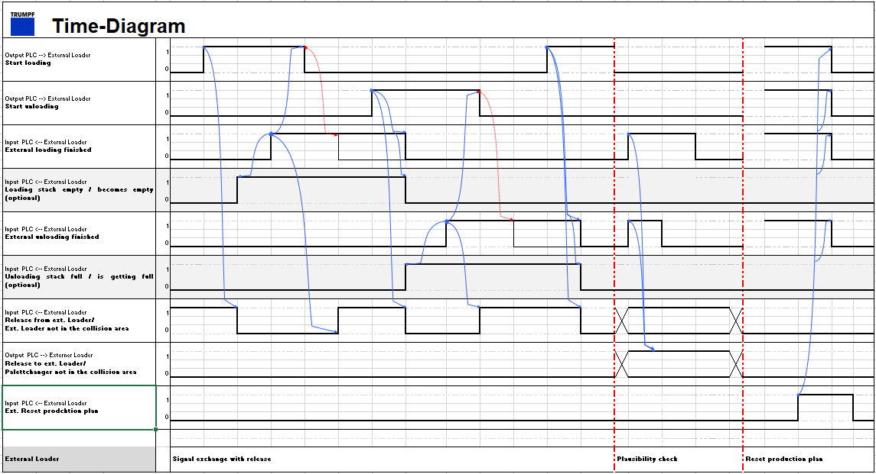

Figure 1: Signal course

# Communication

## Communication hardware interface (Harting plug)

Please take the pin assignment from the document *" Pin assignment and function of the interface (safety-relevant and functional signals) between the machine and the customer-provided automation component"* with the drawing no.: "1001-312"

### Signals Machine → Automation

* **Machine Emergency Stop (non safety)**
* **Machine feed hold – (non-safety)**
* **Automation start pulse**

### Signals Automation → Machine

* **Automation component feed hold – (non-safety)**
* **Machine start impulse**
* **Machine acknowledgment / restart safety device**

## Modbus communication

### Definition of Modbus interface

The external automation is connected to the machine via Modbus TCP using 64 bytes (512 bits) of input coils and 64 bytes (512 bits) of output coils. Input and output coils all start from 0. Detailed configuration is listed below.

Machine is configured as a Modbus Server. Automation IP address needs to be in listed if it’s in same network segment.

|  |  |
| --- | --- |
| Machine IP Address | 172.29.109.1 |
| Automation IP Addresses | 172.29.106.20~  172.29.106.29 |
| Subnet Mask | 255.255.0.0 |
| Port | 502 |
| Input Coils | 64 bytes |
| Output Coils | 64 bytes |

### Signals Machine → Automation

* **Loading the external automation component 🡪 Start loading**
* **Unloading the external automation component 🡪 Start unloading**
* **Enable signal to automation component/ loader/ unloader 🡪 Start/Acknowledgment to external component**
* **Heart beat signal -> 100ms on, 100ms off**

The signals **“Start labeling”** **and “Acknowledge group alarm”** are not used.

#### Digital interface

|  |  |  |  |
| --- | --- | --- | --- |
|  | Byte | Bit | Description |
| +0 | 0 | Start loading |
| +0 | 1 | Start unloading |
| +0 | 2 | Enable signal to loader / unloader |
| +0 | 4 | Start labeling |
| +0 | 5 | Acknowledge group alarm |
| +8 |  | Technology-specific digital signals [4 byte] |
| +9 |
| +10 |
| +11 |
|  | +14 | 7 | Heat beat Signal |

The following signals are still sent via Harting plug:

* **Machine Emergency Stop (non safety)**
* **Machine feed hold – (non-safety)**
* **Automation component start pulse (not used in current machine program logic)**

### Signals Automation 🡪 Machine

* **Loading of external automation component finished**
* **Unloading of external automation component finished**
* **Enable signal to machine**
* **Reset external automation component/ production plan**
* **Cumulative error of automation component**
* **Machine start impulse 🡪 Start/ acknowledge to machine**
* **Loading stack empty, abort (optional)**
* **Loading stack becomes empty, material is still being loaded (optional)**
* **Unload stack full, abort (optional)**
* **Unload stack is getting full, material is still being unloaded (optional)**
* **Heart beat signal -> 100ms on, 100ms off**

The signal **“Labeling completed”** and **“machine start impulse”** is not used.

Currently (optional) signals are not used on machine side.

#### Digital interface

|  |  |  |  |
| --- | --- | --- | --- |
|  | Byte | Bit | Description |
| +0 | 0 | External loading completed |
| +0 | 1 | External unloading completed |
| +0 | 2 | Enable signal from external unit / External unit not in collision area |
| +0 | 3 | Ext. Reset, production plan |
| +0 | 4 | Labeling completed |
| +0 | 5 | Group alarm |
| +0 | 6 | Start/ acknowledge to machine |
| +0 | 7 | Loading stack empty (Abort) |
| +1 | 0 | Loading stack becomes empty, material is still being loaded |
| +1 | 1 | Unload stack full (Abort) |
| +1 | 2 | Unload stack is getting full, material is still being unloaded |
| +8 |  | Technology-specific digital signals [4 byte] |
| +9 |
| +10 |
| +11 |
| +12 |  | Cause of error |
| +13 |
|  | +14 | 7 | Heat beat signal |

The following signals are still sent via Harting plug:

* **Automation component feed hold – (non-safety)**
* **Machine acknowledgment / restart safety device**
* **Machine start impulse （not used in current machine program logic）**

### Telegram transfer

Various external units require additional process parameters such as program number, target and actual quantity.

For this purpose, an area for the transmission of data is appended to the digital interface, the function of which is described below.

The communication structure should be as compatible as possible with the already implemented telegram data structure so that existing telegram data can be converted as easily as possible. The toggle and checksum algorithm was identified as problematic when connecting an external unit to the telegram protocol developed by Trumpf. Therefore, data consistency is realized by means of a strobe signal. This signal is written to "1" at least 20ms after the data has been applied and is only reset after the data transfer has been acknowledged.

Signals Automation 🡪 Machine

|  |  |  |
| --- | --- | --- |
| Byte | Bit | Description |
| +14 | 0 | Data acknowledge |

Signals Machine 🡪 Automation

|  |  |  |
| --- | --- | --- |
| Byte | Bit | Description |
| +14 | 1 | Data send finish |



Figure 2: Signal course at data interface

#### Loading telegramm 0x73

|  |  |  |  |  |  |
| --- | --- | --- | --- | --- | --- |
|  | 15 |  | Telegram – Source **0xB0 (MMC)** | | Telegram ID. |
|  | 16 |  | Telegram – Number **0x73** | |  |
|  | 17 |  | Telegram – Length **44** | |  |
|  |  |  | Telegram – User data | |  |
|  | 18 |  |  | No. of characters in program name [0-25] | |
|  | 19 |  |  | Program Name (string with max. 25 characters) | |
|  |  |  |  |  |  |
|  | 43 |  |  |  |  |
|  | 44 |  |  | Required quantity [0-65535] |  |
|  | 45 |  |  |  |  |
|  | 46 |  |  | Actual quantity [0-65535] |  |
|  | 47 |  |  |  |  |
|  | 48 |  |  | Loading stack number |  |
|  | 49 |  |  | Unloading stack number |  |
|  | 50 |  |  | Suction cup group number 1 |  |
|  | 51 |  |  |  |  |
|  | 52 |  |  | Suction cup group number 2 | |
|  | 53 |  |  |  |  |
|  | 54 |  |  | Suction cup group number 3 |  |
|  | 55 |  |  |  |  |
|  | 56 |  |  | Suction cup group number 4 |  |
|  | 57 |  |  |  |  |
|  | 58 |  |  | Peeling |  |
|  | 59 |  |  | Double sheet detector |  |
|  | 60 |  |  | Sheet thickness |  |
|  | 61 |  |  |  |  |

#### Unloading telegramm 0x75

|  |  |  |  |  |  |
| --- | --- | --- | --- | --- | --- |
|  | 15 |  | Telegram – Source **0xB0 (MMC)** | | Telegram ID |
|  | 16 |  | Telegram – Number **0x75** | |  |
|  | 17 |  | Telegram – Length **44** | |  |
|  |  |  | Telegram – User data | |  |
|  | 18 |  |  | No. of characters in program name [0-25] | |
|  | 19 |  |  | Program name (string with max. 25 characters) | |
|  |  |  |  |  |  |
|  | 43 |  |  |  |  |
|  | 44 |  |  | Required quantity [0-65535] |  |
|  | 45 |  |  |  |  |
|  | 46 |  |  | Actual quantity [0-65535] |  |
|  | 47 |  |  |  |  |
|  | 48 |  |  | Loading stack number |  |
|  | 49 |  |  | Unloading stack number |  |
|  | 50 |  |  | Suction cup group number 1 |  |
|  | 51 |  |  |  |  |
|  | 52 |  |  | Suction cup group number 2 | |
|  | 53 |  |  |  |  |
|  | 54 |  |  | Suction cup group number 3 |  |
|  | 55 |  |  |  |  |
|  | 56 |  |  | Suction cup group number 4 |  |
|  | 57 |  |  |  |  |
|  | 58 |  |  | Peeling |  |
|  | 59 |  |  | Double sheet detector |  |
|  | 60 |  |  | Sheet thickness |  |
|  | 61 |  |  |  |  |

# Configuration

This chapter provides step-by-step instructions for putting the interface at a L99 Laser machine into operation. All instructions given in the following may only by performed by qualified and skilled persons.

## Hardware

In order to start up the interface for the external loading and unloading unit, the following settings are to be made by the Trumpf service engineer.

Make sure the module is connected correctly in the electrical cabinet. Connect the external loading unit to machine EtherNet switch.

## Configuration External Loader

Vulcan - Configure - Machine Settings:

The External Loader should be selected in Loading Type



Figure 3: Loading type

The safety area is not activated (no checkbox selected) if the machine does not have a light barrier. The automation system is responsible for the safety of the pallet changer.

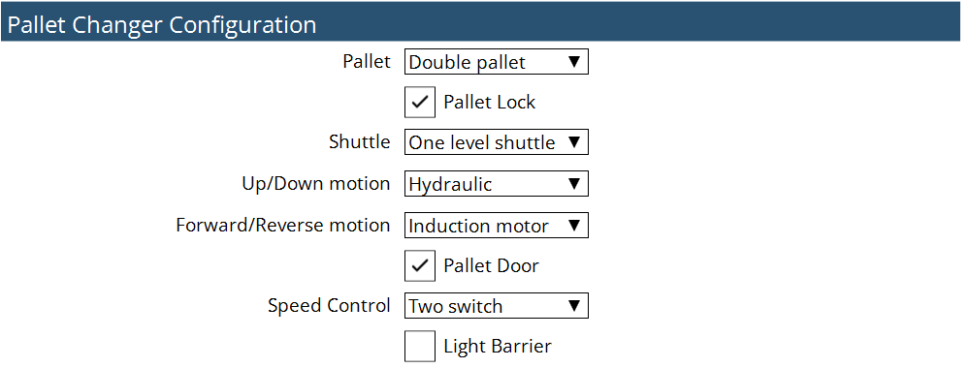

Figure 4: Light barrier belongs to Automation

There could be different machines layout in the field, thus the Sheet Stop Position should be adjusted accordingly.

Vulcan - Configure - Machine Settings:



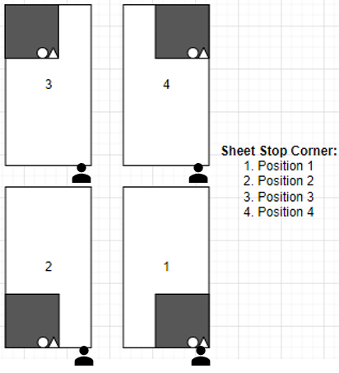

Figure 5: Sheet Stop Position

# List of Figures

Figure 1: Signal course 5

Figure 2: Signal course at data interface 9

Figure 3: Loading type 12

Figure 4: Light barrier belongs to Automation 12

Figure 5: Sheet Stop Position 12